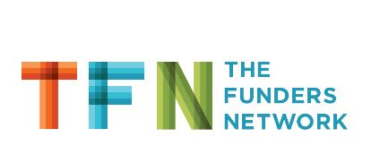

**“The fellowship has provided me with a strong, close knit network of peers with whom I can generate ideas, strategize, confer, and be uplifted by when the work just feels too heavy.”**

**ABOUT PLACES:**

PLACES is a transformational leadership development program for a diverse network of professionals in philanthropy used to build the skills and knowledge to better understand issues of race, equity and inclusiveness, to model the behavior and translate it into grantmaking practices.

PLACES’ touches on every aspect of TFN’s Inclusiveness Framework. The fellowship works to build grant maker capacity and help the philanthropic sector address interrelated issues of community and economic development, environmental sustainability, and regional planning using an explicit lens of social, economic, and racial equity.

**AS A RESULT OF PARTICIPATING, FELLOWS GAIN:**

* An in-depth knowledge of how decisions about growth and development are related to issues of race/ethnicity/class;
* Tools, resources, and best practices to help them increase their effectiveness as grant makers;
* Personal development, coaching, leadership development, and skill building opportunities; and
* Expanded network building opportunities.

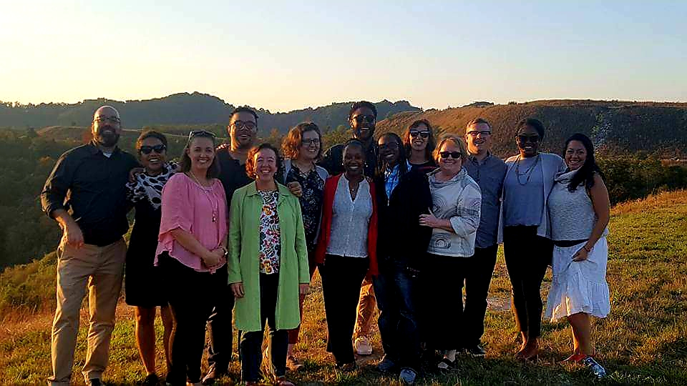

**HIGHLIGHTS**

* The Funders’ Network is a membership organization that helps grantmakers advance strategies to create fair, prosperous, and sustainable regions and communities that offer everyone the chance for a good life. PLACES helps support that mission.
* Each cohort is made up of a diverse group of professionals working for place-based, regional and national philanthropic organizations, or philanthropy serving organizations.
* Over 90 philanthropic organizations in North America and Canada have participated.
* Since 2009, PLACES has graduated over 140 fellows.
* PLACES has a 92% graduation rate.
* 45% of alumni have had promotions or role changes to senior level positions.
* 97% of Fellows have connected formally or informally with alumni and other TFN members.

PLACES FELLOWSHIP

**“The #PLACES journey has been unreal, transformative, and propulsive. #gratitude. Thank you, @fundersnetwork! “**

To learn more about **PLACES**, visit us online!

Funders’ Network for Smart Growth and Livable Communities

[www.fundersnetwork.org](http://www.fundersnetwork.org)

**Contact Staff:**

**Dion Cartwright**

Director of Equitable Initiatives and Leadership Development

dion@fundersnetwork.org

**Marci Ovadia**

Senior Program Associate, Equity Programs and Communications

[marci@fundersnetwork.org](mailto:marci@fundersnetwork.org)

**FREQUENTLY ASKED QUESTIONS**

**Q: How are Fellows selected?**

### A: All fellows go through a competitive application process and are selected based on a variety of factors, especially a commitment to learning about equity in the context of community development and a willingness to invest in their professional and personal growth. An external application review committee reviews all eligible applications and meets over a two-day period to discuss each application. The committee makes recommendations to TFN staff for approval. TFN staff do not have a vote. Final approval is given by the CEO.

### Q: What is the average cost to participate?

A: The average organizational cost for Fellows to participate is up to $6,000. The Funders’ Network for Smart Growth and Livable Communities will cover all of the costs associated with the learning activities (meals, conference calls, meetings, coaching). The candidate’s foundation is expected to cover their time for participation in the program, and any travel and lodging expenses incurred by the fellow during the program.

**Q: How is the Fellowship experience structured?**

A: PLACES fellows attend 4 site visits to various cities over the course of the learning year. Coaching and peer learning is provided throughout the entire experience. In additional to the PLACES curriculum, fellows learn from the people and places we visit. The site visit locations vary each year. The fellowship concludes with a capstone presentation and graduation.

**Q: Am I eligible to participate?**

A: If you have at least one year of experience in philanthropy and are working as a funder or at an organization serving philanthropy you are eligible to participate. PLACES cohorts include diversity in experience, geography, race, age, ethnicity, gender identity and sexuality.

**PLACES ADVISORY BOARD**

* The PLACES Fellowship Program is guided by an advisory board of national and place-based funders used to engage in the TFN Network as part of its ongoing commitment to incorporate issues of equity, fairness, opportunity and access in the fellowship program.
* The advisory board plays a vital role by serving as a guiding body for program development to remain focused on issues of race, class and opportunity in the context of growth and development. Additionally, board members contribute their perspectives and expertise related to implementation of PLACES goals and strategies.

**“Coaching, learning and support through the network has enabled me to lead internal change such as rewriting our theory of change with an explicit racial equity focus and creating a budget for organizational training and assessment.”**

**“PLACES was an extraordinary experience - the people and learning will forever serve to propel me forward as a person and professional committed to justice.”**